Reforma CO
Robert Hoag Rawlings Public Library
September 18, 2017

Meeting Minutes

Welcome everyone In Attendance: Maria (Robert Hoag Rawlings Public Library Pueblo), Federico Freddy M.(UCCS) K.D. (DPL) Nicanor(DPL), Viviana (DPL), Carolina (DPL)
Reformistas that attended Virtually: Lando(UC Denver), Kathie(Colorado Mountain College), Gloria. Charlene, Candy, Lisa M. (DPL).

1. What is Reforma?
- Subscribe to Listserve
- Translations Committee what we offer:
  - Reforma Colorado has translated for different libraries.
  - If your library needs something translated into Spanish give us ample time to translate send what you need translated to: Reformaco.translations@gmail.com also if you just want us to proofread, we can do that as well.
- Reforma CO. will send a reminder on the listserv. with this information.

2. CO-Teen Lit Conference (call for volunteers)
- Reforma Co. has provided $320 in funding to 8 students to attend the CO-Teen Literature conference. It is an all day conference. Reforma does not help with the selection process of which students get to attend. Teen Literature selects the students.
- Nicanor: Hannah Evans from Smiley has staff it in the past, asking for volunteers that might be interested.
- The conference is April 14. 2nd week of April.
- Asking for volunteers to staff an exhibit table the day of the conference. If we have enough volunteer we could take turns attending the conference if interested.

3. Introduce/Mention all and New officers:
- Viviana: Reforma Colorado President
- Candy: Vice president, Conference Chair, Facebook admin.
- Mary: Past President
- Nicanor: Chapter Representative - central region
- Lando: Treasurer
- KD Hubbard: WebMaster
- Carolina: Secretary

4. Treasurer's report (Lando attending virtually)
- Viviana: Introduces Reforma CO. treasurer: Lando submits reports to IRS, maintenance all financial reports for Reforma CO. He is resourceful. He is like our George Washington. (Jorge Washington) of Reforma CO.

- The current amount in the bank is $7324.27 this is the highest amount that we ever had. I remember when we use to have $50 in the bank.
- RNC VI donation
  - Reforma Colorado donated $500 to the RNC VI - We receive a nice acknowledgement letter.
  - Conference was canceled. We have not heard back from reforma. Do not know if we are getting the money back or not. Chapters have help us in the past.
- 2017 Reforma CO. Conference finance update
  - Income: $3028.32
  - Total Expenses: $967.78
  - Net profit (Income - Expenses): $2060.54
- Attached you will find the 2017 Reforma Colorado Conference Financial Summary Report.
- Last five years DPL hosted the mini conference and did not charge. This is how we were able to keep the cost down.
- Small Grants: This is the 3rd year that Reforma Colorado provides small grants of $100. The application has been updated on the web. There are 4 different deadlines for the grants. Details here.

5. Nominations for Office 2018
- Interested in running for office for Reforma Colorado. 2018 Let Mary from Auraria Campus know that you are interested in running for Office email: reformacolorado@gmail.com
- If you are interested in shadowing one of the officers your are welcome to do so as well.

6. National Reforma.
  - You can be involved at different levels. Nicanor: share committees that are available at the national level.
  - List of Committees:http://www.reforma.org/committees
  - Who is the president for Reforma National?
    - Tess Tobin (president)
    - Madeline Pena Feliz (vice president/ President elect)

7. Goals for 2017-2018
- To reach different members around the state.
- Team Development. Learn from each other and build new relationships. Pilot program might come up. What kind of development do you want to see?
- Conference
  - It will be in May, Looking for connections, different ways to volunteer, become a presenter, volunteer the day of, food, presenters, hosting of presenters, technical, local arrangements, evaluations. In 2013 the conference was a mini conference. It has been growing in size. Bring your knowledge and share it out. 2018 conference will be a full day conference.
  - Free registrations for presenters

- Call for Volunteers for Mid-Winter Feb 9-11 2018 Convention Center.
- Volunteers needed for Saturday Feb 10 7-11p.m. more information to come.

8. Round table member announcements
- Maria mention the Retablos Exhibition in Hispanic Resource Gallery.
- At the Rawlings library they had A night of flamenco dance and music by flamenco underground.
- The pueblo Chile & Frijoles Festival is this Friday, Sept. 22-24
- Papel Picado Craft
- Nicanor share about the Shelf Life Podcast
Shelf Life is a podcast produced by the Rodolfo "Corky" Gonzales Branch of the Denver Public Library. Episode 23 Talks about the New Americans Project: https://archive.org/details/@shelf_life_podcast
- Lando -talk about the student diversity of Community College of Denver, Metropolitan State University of Denver, and the University of Colorado Denver.

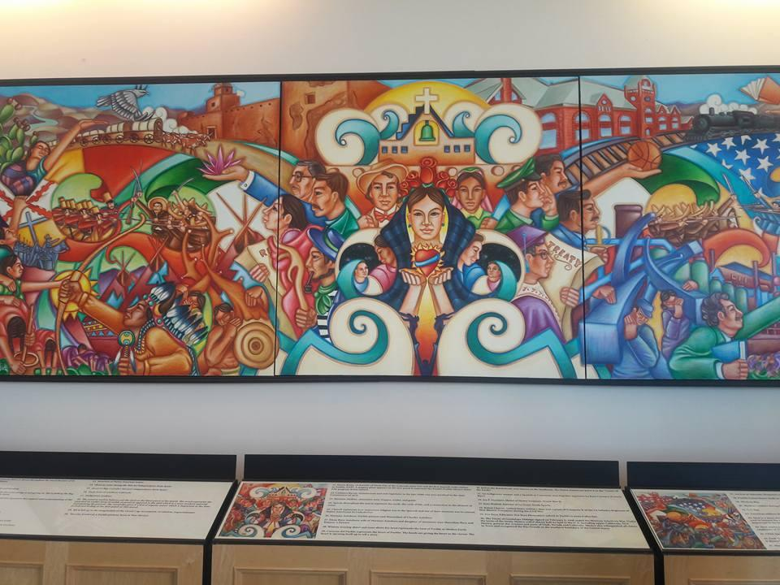
- After the Meeting we got a tour of the Robert Hoag Rawlings Public Library. Here is a beautiful picture of mural that depicts Pueblo.

